**Java Script theme**

1. In HTML, we created simple web pages using different html tags. Now i want to create different validations to the documents we have created.
2. For example i am creating an application, where it need registration to the candidate to get access to the application. User need to enter some details which are mandatory and on which some have restrictions like minimum of 8 characters and maximum of 20 characters. Some have to be like both upper and lower cases and also must include special characters .



The above form with different conditions can be created by using Java Script.

1. Lets take a look at how actually validations occur. Lets i have a form, where password must be min of 8 chars and max of 20 chars and both with upper and lower cases and must have a special characters.

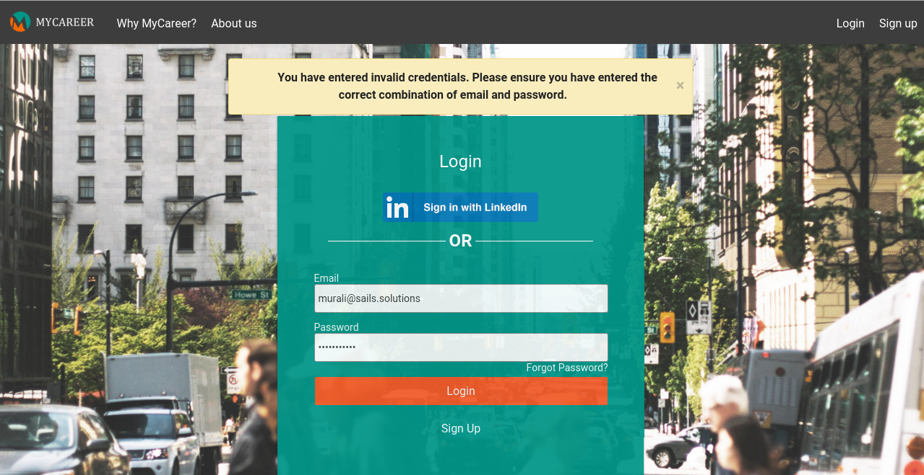

The above validation can be done by using functions. Function captures user information before submitting to the server, it first validate the user input by using regular expressions. It it is valid then send the data to the server for validation.

1. If i want allow user to modify the content of the document without reloading the page. Inorder to that we use DOM methods.

{image}

1. So far we have simple documents and links. If i want to do some validation or some validation when user cliked on something or hover over something. It can be done by using DOM Events.

{image}

1. Some times ,some functionalities are not usefull in other browser because of compatability issue or because of their notation. Let take a loot at below two sceen shots.

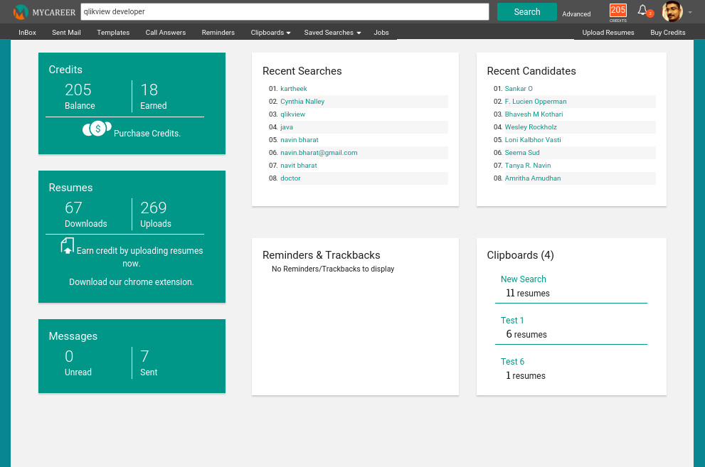

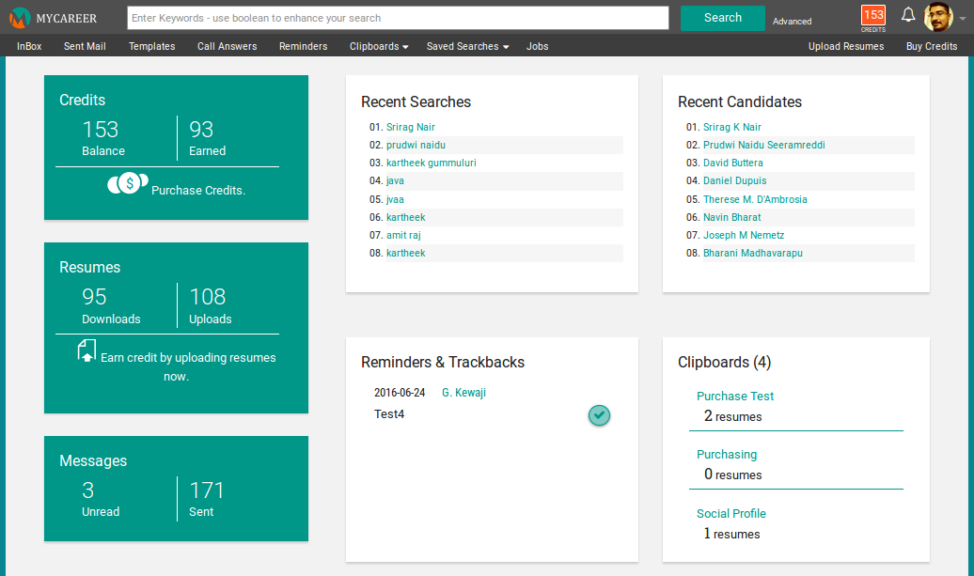

1. Some time we want to change the user display based on the screen size. Lets take a look at below images, on these the modal size is varies based on the user screen size.

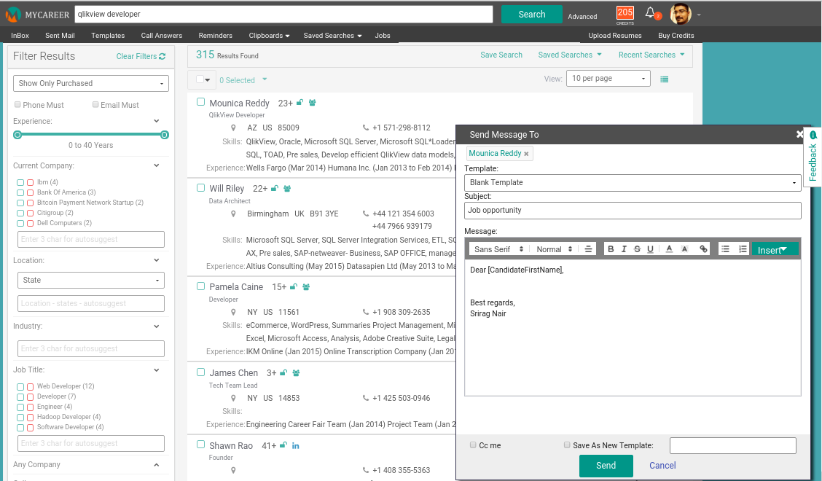

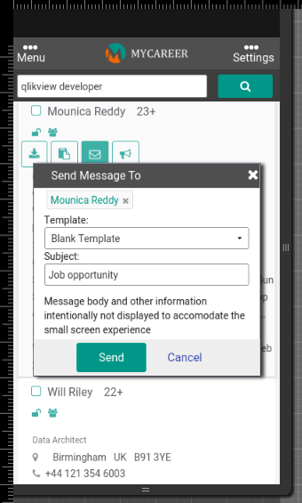

10. Sometimes we have to identify the user location i.e from where user accessing out website or the product.

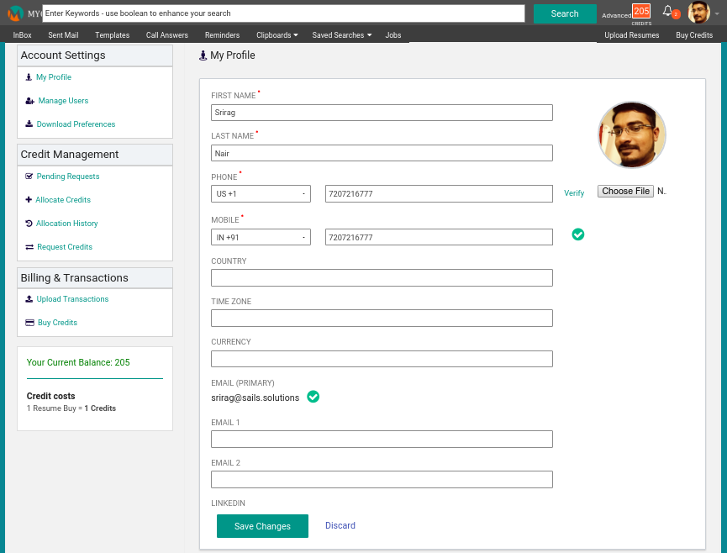

In order to identify the location window.location allows to capture the location of the user who accessing the product or the website.